Unit 7 day 8 Level B

Hi everyone! Today I want to start off by having you write out these verbs listed on the worksheet below on a separate sheet of paper. Then I want you to use them in a sentence.

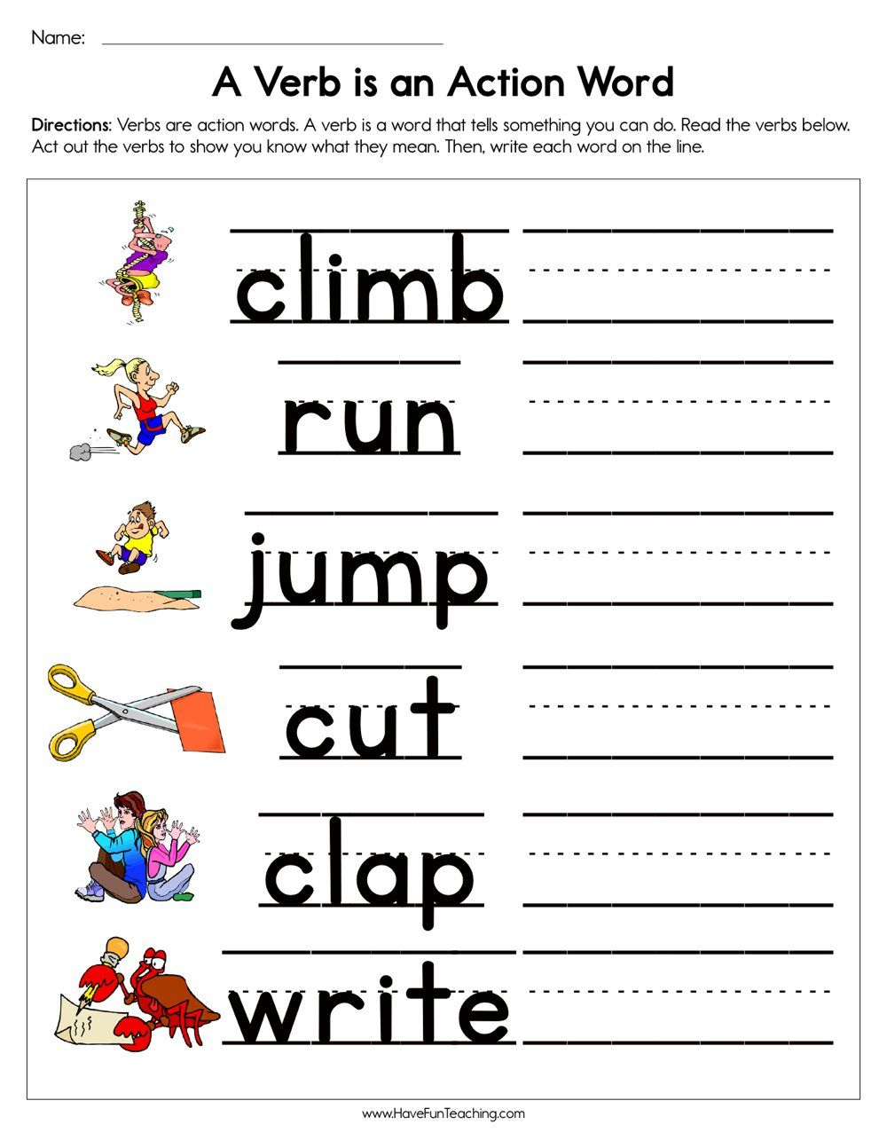

For our next activity I want you to think about the words now and later. Can you use those words in a sentence?

For your last activity, I want you to draw a picture of something you are looking forward to doing, as the weather gets nicer. Have a great day!